Department of Trade and Taxes

Government of NCT of Delhi

Form DVAT 19

PART - A

[See Rule 10]

Statement of Trading Stock and Raw Material as on the date of registration

1. Registration No./TIN

2. | Full Name of Dealer
3. | Total | Value | of | the | Description* |  |  |  |  |  | Value (Rs.) |  |  |  |  |  |  |  |  |  |  | Input Tax (Rs.)
 | trading | stock | and | raw
 |  |  |  |  | (i) Trading Stock
 | material as on the date
 |  |  |  |  | (ii) Raw Material
 | of registration takes
 | effect
 | effect |  |  |  |  | Total
 | (* Please complete Part B)

4. Verification

I/We ________hereby solemnly affirm and declare that the information given hereinabove is true and correct to the best of my/our knowledge and belief and nothing has been concealed therefrom. Further certified that the particulars indicated above are the correct version of the documents, which are in my/our possession and can be produced before the Value Added Tax Department on demand.

Signature of Authorised Signatory | _______________________________________
Full Name (first name, middle, surname) | _______________________________________
Designation/Status | _______________________________________

Place

Date

Day | Month | Year

Instructions for filling the statement (For details please refer to Section 20 and Rule 10)

- The statement has to be submitted within 7 days from its registration takes effect.

- The statement has to be furnished by a registered dealer wishing to claim credit under section 20 (1).

- The goods on which credit is being claimed should be physically held by the dealer on the date its registration takes effect.

- The goods on which credit is being claimed should have been purchased on or after 1st April, 2005 from a dealer registered under Delhi Value Added Tax Act, 2004 and the dealer should have in his possession the invoices.

- The tax credit on the stock cannot be claimed-

  - for finished goods manufactured out of tax paid raw material or capital goods;

  - for opening stock held outside Delhi.

- The dealer should claim the entire amount of credit to which he is entitled in a single statement.

Form DVAT 19

PART - B

(i) Details of trading stock on which credit has been sought
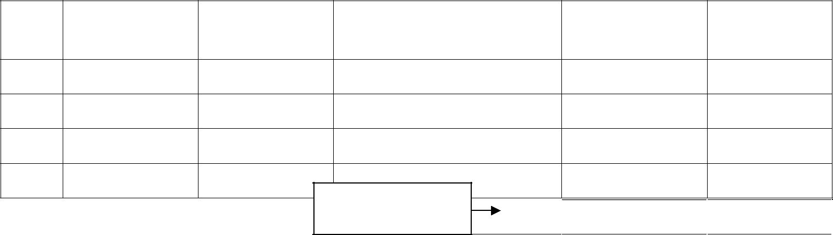
S.No. Tax Invoice | Tax Invoice | Supplier Registration no./ | Value (Rs.) | Input Tax
date | No. | TIN under the Act |  | (Rs.)

Carry total to main form to (3)(i)

Total 

(ii) Details of raw material on which credit has been sought
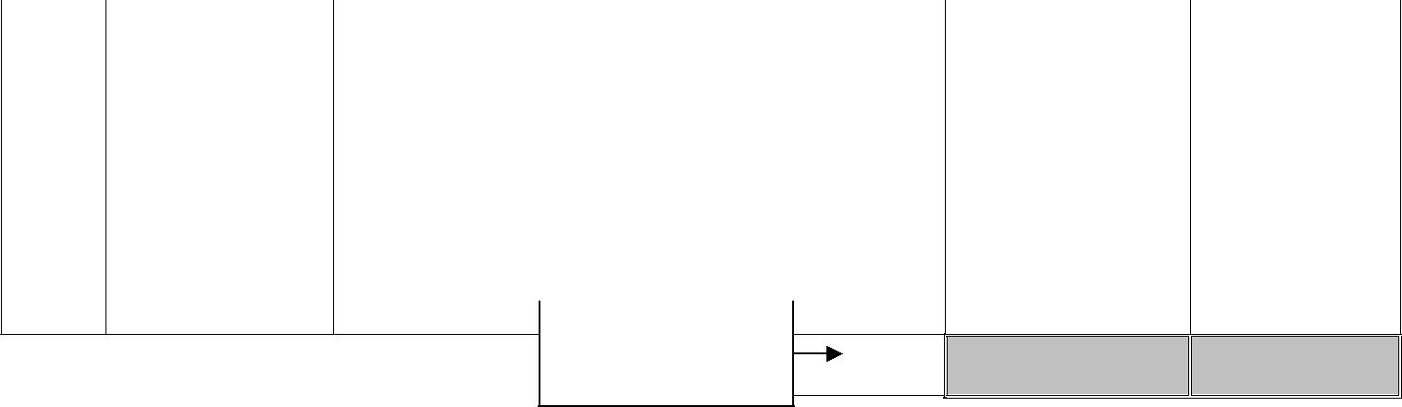
S.No. Tax Invoice | Tax Invoice |  | Supplier Registration no./ |  | Value (Rs.) | Input Tax
date | No. |  | TIN under the Act |  |  | (Rs.)

Carry total to main | Total
form to (3)(ii) | Total

(iii) Verification

I/We __________________________________________ hereby solemnly affirm and declare that the information given hereinabove is true and correct to the best of my/our knowledge and belief and nothing has been concealed therefrom.

Signature of Authorised Signatory | _______________________________________
Full Name (first name, middle, surname) | _______________________________________
Designation/Status | _______________________________________

Place

Date

Day | Month | Year

